When Journalists Must Advocate for Themselves
A lesson on the changing role of media and conceptions of newsworthiness

Summary
Students will evaluate a July 4th front page that advocates for freedoms and for a critical awareness of government actions. Then, after reading background information and Facebook discussions about the role of the newspaper and the purpose of page one, students will debate whether the page was an appropriate reflection of the newspaper’s purpose. This is the fifth and final lesson of a week-long unit introducing news literacy.

Objectives
- Students will analyze the role of newspapers in democracy and explore the challenge of being impartial publishers of information.

- Students will examine the arguments for and against an advocacy press.

- Students will explain and defend their position on the role of the press in America.

Common Core State Standards
CCSS.ELA-Literacy.RI.9-10.8 | Delineate and evaluate the argument and specific claims in a text, assessing whether the reasoning is valid and the evidence is relevant and sufficient; identify false statements and fallacious reasoning.
CCSS.ELA-Literacy.W.9-10.8 | Gather relevant information from multiple authoritative print and digital sources, using advanced searches effectively; assess the usefulness of each source in answering the research question; integrate information into the text selectively to maintain the flow of ideas, avoiding plagiarism and following a standard format for citation.
CCSS.ELA-Literacy.RI.9-10.5 | Analyze in detail how an author’s ideas or claims are developed and refined by particular sentences, paragraphs, or larger portions of a text (e.g., a section or chapter).
CCSS.ELA-Literacy.RI.9-10.6 | Determine an author’s point of view or purpose in a text and analyze how an author uses rhetoric to advance that point of view or purpose.

Partnership for 21st Century Skills—Student Outcomes
Skills | P21 outcomes
Critical Thinking | - Reason effectively  - Use systems thinking  - Make judgments and decisions
Communication | - Communicate clearly
Information Literacy | - Access and evaluate information  - Use and manage information
Media Literacy | - Analyze media

Length
50 minutes

Materials/Resources
1. Virginian-Pilot pdf (one for each student)
2. ACES story (one per group of 3)
3. Facebook comments page (one per group of 3)

LESSON STEP-BY-STEP

1. Building background—10 minutes

Explain to students that today they’ll be discussing the value of journalism and how to best advocate for a free press in a democracy. Sometimes, journalists have to advocate for themselves, going out of their way to remind the public why they exist, who they serve, and that their role is enshrined in the very fabric of our Constitution. However, for some, doing so crosses the line between an impartial press and advocacy press. If a journalist is advocating for something, what does that mean? Does it violate the expectations we have that newspapers will provide information and not push an agenda? What if that agenda is something most people would agree is good? What if that position is supported by our very Constitution?

Explain that students are going to read and analyze a recent front page that received mixed feedback on whether the content was appropriate. This summer, for the 4th of July, the Virginian-Pilot published a front page complete with quotes and graphics explaining, advocating, and defending certain freedoms in our country. You will first spend some time reading this front page, and then you’ll get more background information about how it was created and what others thought about it.

(Hand out pdf of front page, and give students 10 minutes to read and process it. Ask them to make notes on a separate piece of paper about their original reactions. Did they like it? Did they like the content and the visuals? One or the other? What did they think the message was?)

2. Think-Pair-Share—20 minutes

Next, group students into groups of 3. Allow students to pick a task (reader, writer, speaker), and hand out the Facebook comments and the ACES story that goes with the text. Instruct the reader to quietly to read the comments and story to the group. Then, the group should spend 10 minutes discussing their reactions and whether they agree with any of the comments. The writer should keep notes on the group’s reaction and comments to the feedback. Finally, the group should discuss and come to a consensus about whether they think the front page was appropriate, reflected quality journalism, and why (or why not).

3. Present—20 minutes

Have each group explain their argument to the class (the speaker talks), and allow the groups to debate it out a little. Finally, as a class, take a vote on whether the page was appropriate and professional. Was this advocacy? Was it journalism? Was it both? And finally, are students OK with the outcome? Can they live with it either way? Do they even care?

4. Follow-up—Take home exercise

Directions: Write a 200-word letter to the editor in response to this front-page design. Be sure to state your opinion about whether you believe the front page was appropriate or inappropriate and why. You must back up your claim with at least three specific facts or references. You can cite recent national issues, other media coverage, political documents, and/or historical knowledge to support your argument.

Grading Rubric
 | Fair  (1 point) | Good  (3 points) | Excellent  (5 points) | Total points
Argument & voice | Student’s argument is unclear or indiscernible. | Student’s argument is clearly stated but lacks appropriate tone (ie too casual, too forceful). | Student concisely states opinion in direct, respectful manner. Argument is well-reasoned and logical | _____/5
Clarity, structure, grammar & punctuation | Letter has three or more errors in grammar or punctuation. The argument lacks cohesion and a logical format. Facts are referenced without transitions. | Letter has less than three errors in grammar or punctuation. The argument is clear but lacks transitions or a proper conclusion. | Letter is free from grammatical errors and uses correct punctuation. The argument is clear and builds logically from a statement of opinion, to supporting references, to a conclusion. | _____/5
Factual references | Only one reference is cited. Reference lacks any apparent connection to the argument, or connections are poorly drawn. | Only two references are cited. References do not directly relate to argument. | At least three references are cited. References are clear and accurately presented. References directly support argument. | _____/5
Total points |  |  |  | _____/15

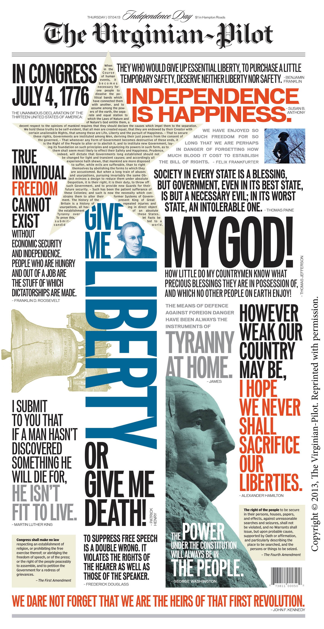
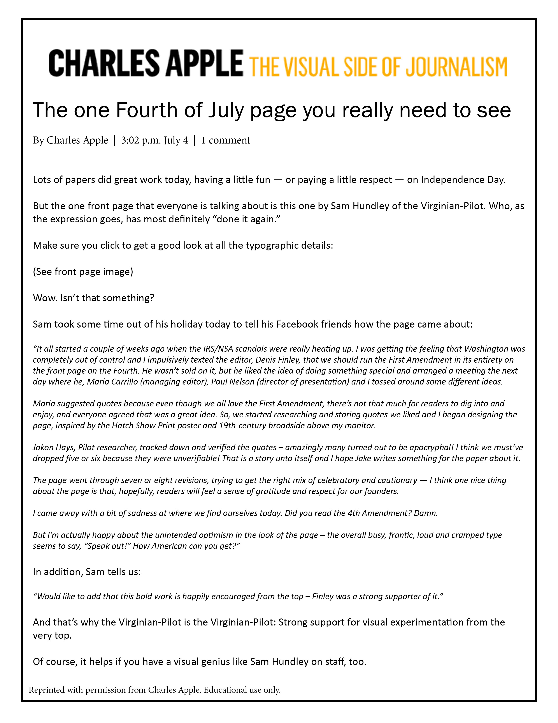

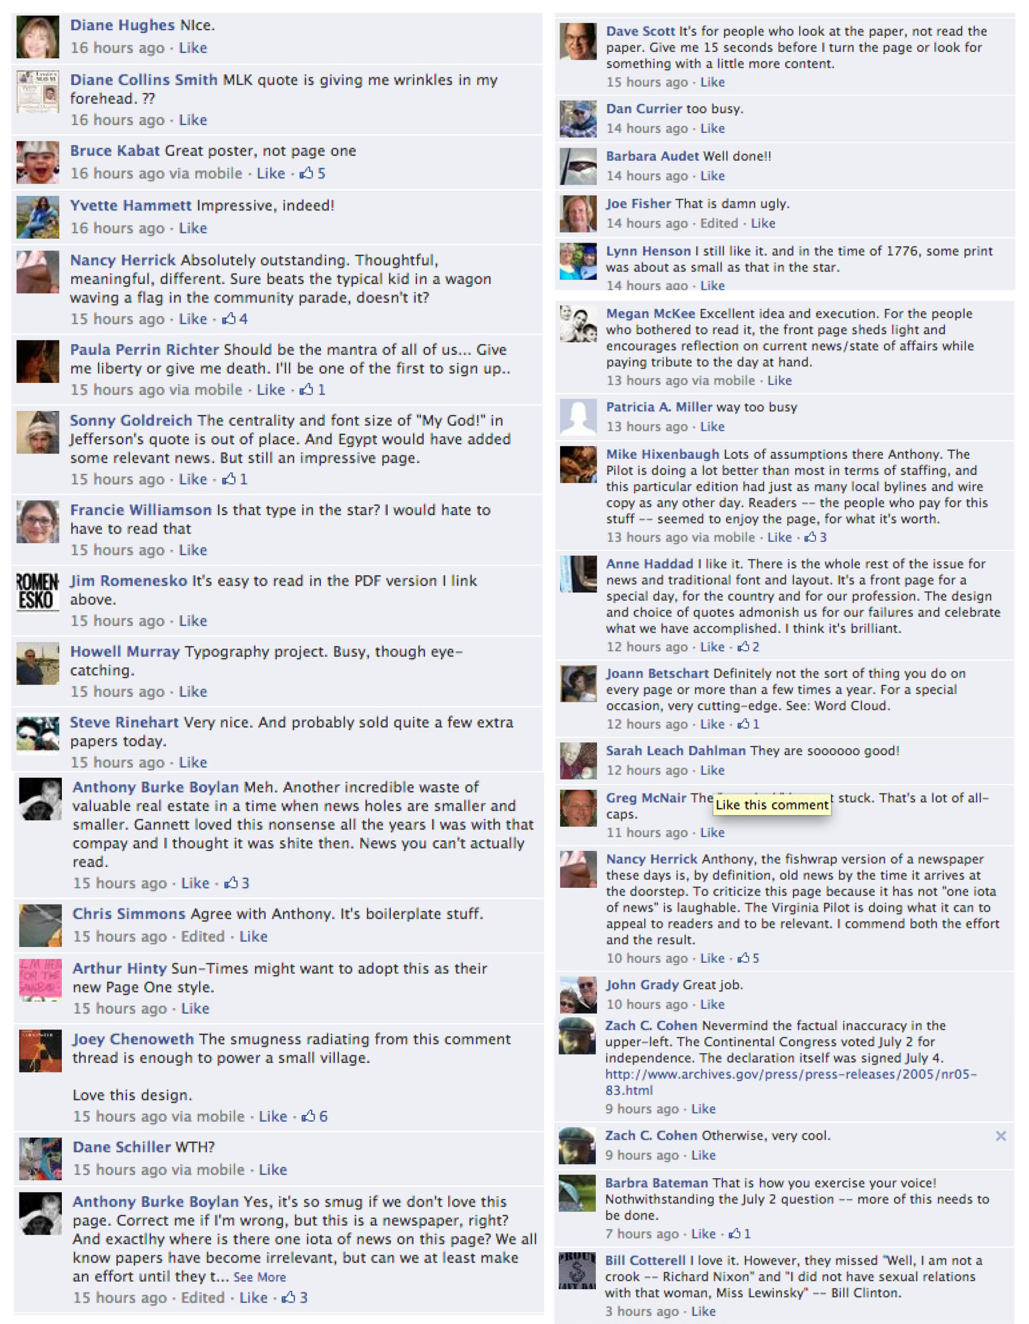Reprinted with permission from Jim Romenesko. Rights to educational use granted.

