News Literacy Lesson Plan Template

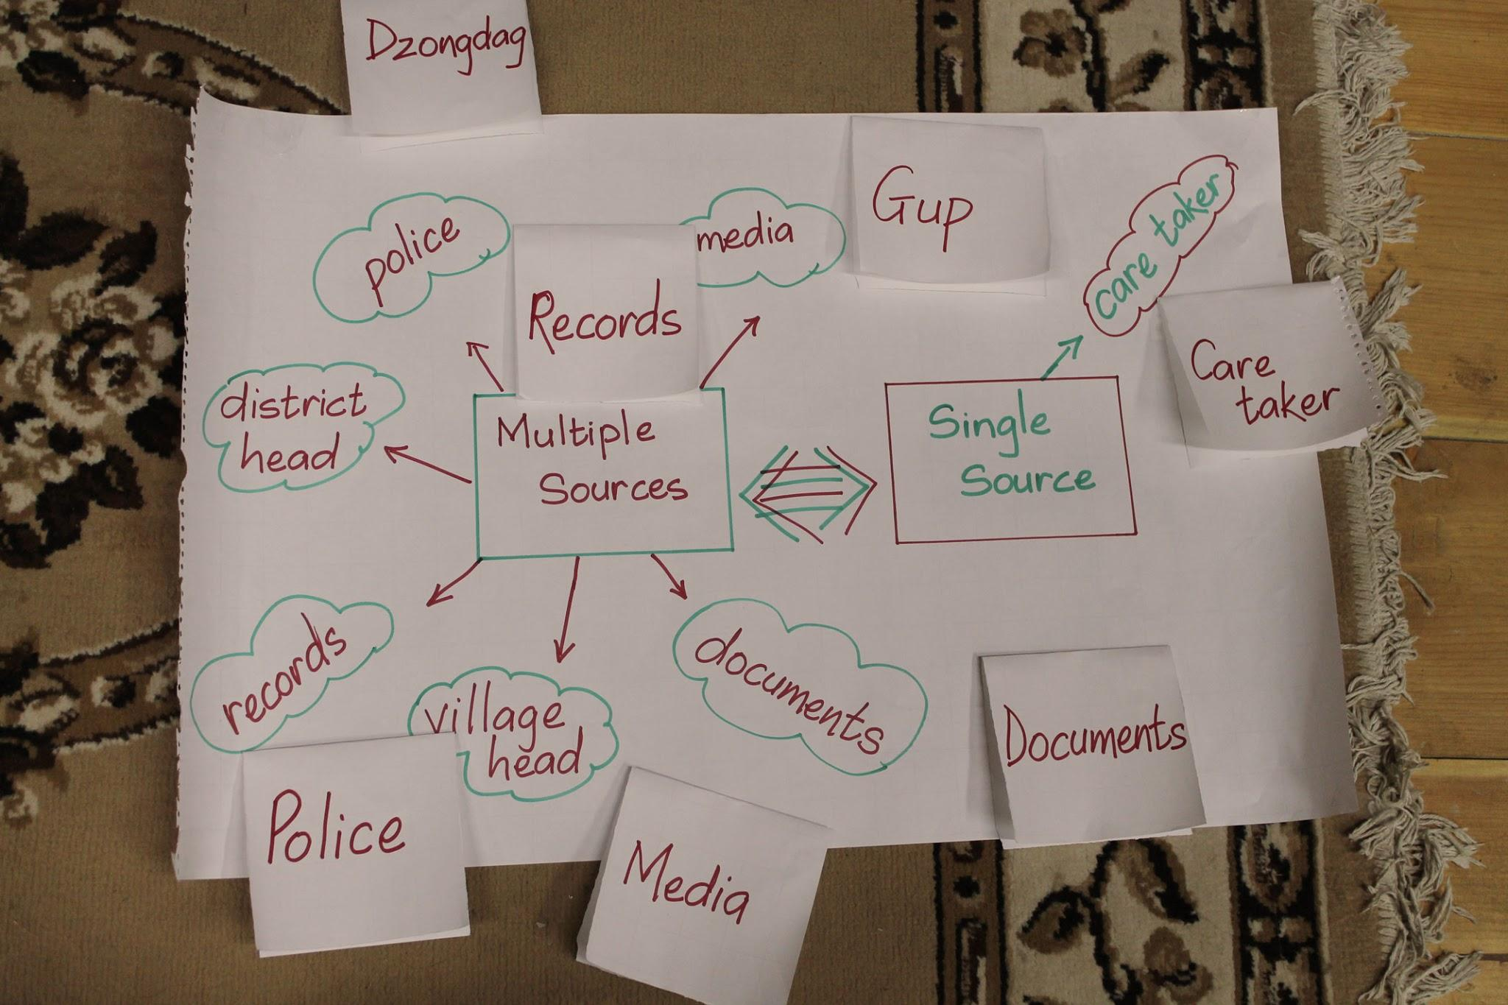
Introduction and Motivation:
Here, you write your thoughts about how to engage students with the lesson by connecting it to life as they live it. Maybe you simply start with questions. Maybe a quick exercise.

SMART Objective:
SMART is an acronym that stands for Specific, Measurable, Attainable, Realistic and Time-based. Here’s an example: “At the end of the lesson , the students will be able to identify steps involved in the democratic process through the creation of a chart of the creation of a law”.

Standards met in this lesson:
- Which State standards does this lesson connect to? List them
- Which elements of the Common Core State Standards are supported by this lesson?
- Listing these will help the next user of your lesson plan where best to add this to their course.

News Literacy concepts or skills to be incorporated
- Which elements of the Stony Brook Model does this lesson illustrate or teach? Listing them will help the next user of this lesson plan better understand News Literacy and better support News Literacy goals

Values/Life Skills:
This section helps the teacher think about applications outside the classroom. Just list and briefly describe.

Suggested Vocabulary:
Shared understanding can evolve from shared terms. If there are terms of art or unusual words in play in this current event, make sure students understand them.
Teachers should explain and replace vocabulary words as needed.

Strategy for the lesson:

Step-by-Step describe how this lesson evolves. This process helps plan lessons that fit in their allotted time.

Pivotal Questions:
- A series of open-ended questions written carefully ahead of time.
- These questions guide discussion and probe for understanding.
- Some questions merely open space for students to share.

Lesson Summary:
(Best if there is at least one at the midpoint and another at the end)
This may be a series of points the teacher will cover
Or, it can be a series of questions the teacher will ask to reinforce the lesson or lead students to the next set of questions or conclusions.

Lesson extensions and connections:
Often bridges the lesson to future instruction and may, at times incorporate the original aim/problem. May be part of a final or concluding summary.

Attachments, materials and sources:
This is where you provide background readings you find, links to multiple reports on the same event and photos, videos and other materials that will make this lesson a multi-media experience.

It’s best if you provide annotations

